## Loan Processing Application

The input given to the application:

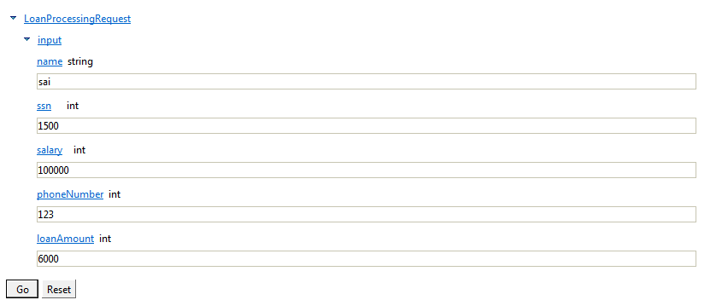

Depending on the input provided in the loan application, the loan request is either accepted or rejected.

The junit test case contains all the valid and invalid input for each of the web services. Following are the different types of valid/invalid input

Please disregard the errors that appear in the bpel file. This was because I tried to rename the invoke activites. However, the application runs correctly.

The BPEL project is named “**Parthasarathi_HW3”**

The web services are inside the project “**SimpleSOAPExample”(inside the webcontent directory)**

## Constraints for valid input:

**SSN:** The loan processing system assumes that valid ssn is in the range 1000 – 2000. Out of this, the loan processing system has info that the SSNs 1000 – 1500 have “good credit score” and “employment verified”. For the SSNs from 1500 – 2000, “employment check” and “credit check” fail.

**Salary:** Salary should be >= 50000 and <= 500000.

**phoneNumber:** Valid phone number is in the range 100 – 200.

**loanAmount:** The system accepts loan requests starting from 5000 to 100000.

Deployment Details:  
The web services are deployed in Tomcat v7.0 Server. Initially the java class files are written and then right click **“Web Service ->Create web service”**. Select **“Publish the Web Service”.** You can test the web service by right clicking the generated wsdl files**(found inside Web Content->WSDL)** and selecting **(Web Services-> Test with Web Services Explorer).**

After the web services are deployed and tested, the application is deployed on the ODE server. Since I used ODE server for running the bpel process and Tomcat 7.0 server for deploying the web service, I changed the ports of tomcat server.

## Sample Input & Output:

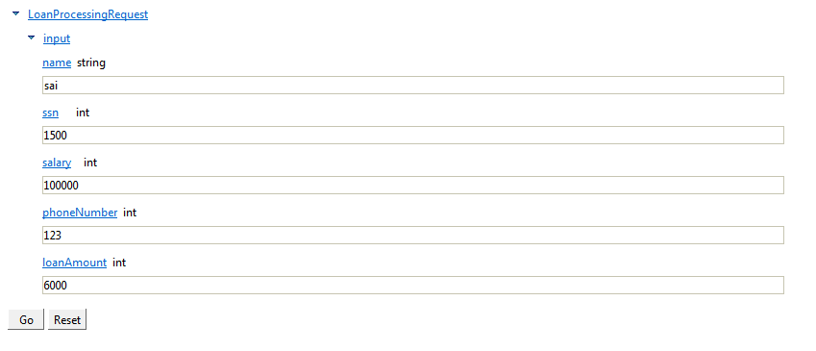

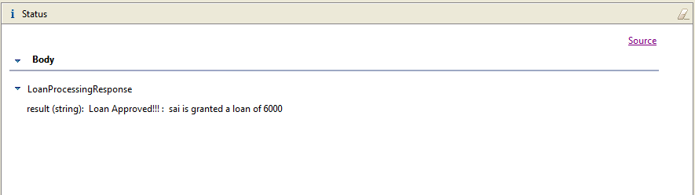

When the input constraints are not satisfied, then the “Verification” web service says that the applicant is not verified. The application is returned the following output:

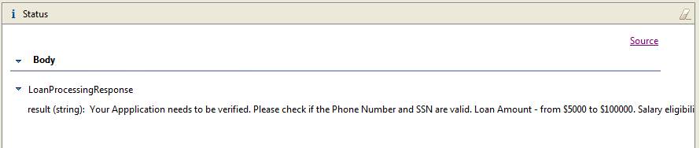

Similarly, when the **“employment check”** and **“credit check”** services find that the applicant is not eligible, the system displays the following output:

